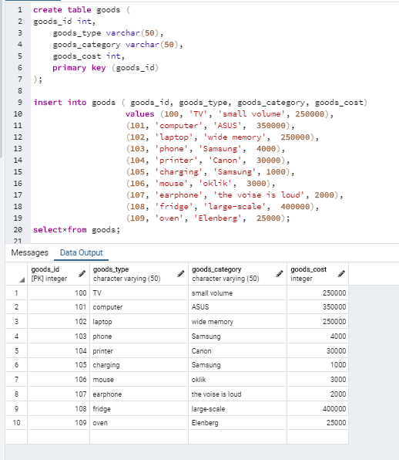

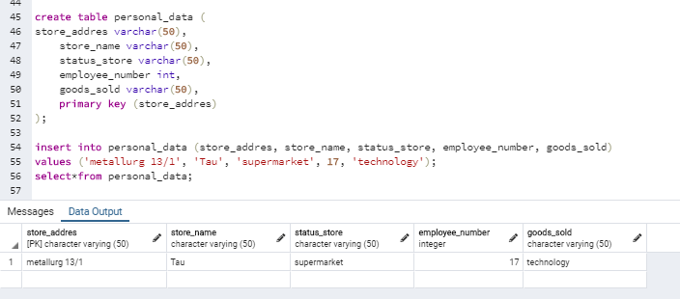

create table goods (

goods_id int,

goods_type varchar(50),

goods_category varchar(50),

goods_cost int,

primary key (goods_id)

);

insert into goods ( goods_id, goods_type, goods_category, goods_cost)

values (100, 'TV', 'small volume', 250000),

(101, 'computer', 'ASUS', 350000),

(102, 'laptop', 'wide memory', 250000),

(103, 'phone', 'Samsung', 4000),

(104, 'printer', 'Canon', 30000),

(105, 'charging', 'Samsung', 1000),

(106, 'mouse', 'oklik', 3000),

(107, 'earphone', 'the voise is loud', 2000),

(108, 'fridge', 'large-scale', 400000),

(109, 'oven', 'Elenberg', 25000);

select*from goods;

create table reseipt (

reseipt_id int primary key,

order_time1 varchar(50),

client_full_name1 varchar(50),

goods_type1 varchar(50),

goods_cost1 int,

payment_type varchar(50)

);

create table personal_data (

store_addres varchar(50),

store_name varchar(50),

status_store varchar(50),

employee_number int,

goods_sold varchar(50),

primary key (store_addres)

);

insert into personal_data (store_addres, store_name, status_store, employee_number, goods_sold)

values ('metallurg 13/1', 'Tau', 'supermarket', 17, 'technology');

select*from personal_data;

create table delivery (

delivery_id int,

client_full_name varchar(50),

client_phone int,

client_addres varchar(50),

delivery_time varchar(50),

primary key (delivery_id)

);

insert into delivery (delivery_id, client_full_name, client_phone, client_addres, delivery_time)

values (22112001,'Baybaketova Asel', 87477683090, '3-1-18', '22.11.20. 13.30'),

(22112001,'Roma Muka', 87477683091, '4-5-13', '22.11.20. 13.30'),

(23112002,'Aldazharov Merey', 87477683092, 'metallurg 12', '23.11.20. 15.30'),

(24112001,'Rolan Joldybayev', 87477683093, '2-1-45', '24.11.20. 13.30'),

(25112001,'Aika Token', 87477683094, '3-4-15','25.11.20. 16.00'),

(26112001,'Aru Rakym', 87477683095,'1-5-40','26.11.20. 18.30'),

(27112001,'Jania Bekzhan', 87477683096, '9-2-32','27.11.20. 19.30'),

(28112001, 'Olzhas Oryn', 87477683097, 'abai 13','28.11.20. 17.00'),

(29112001, 'Koldas Bayan', 87477683098,'2-1-4','29.11.20. 13.30'),

(30112001,'Jakyp Murat', 87477683099,'1-32-98','30.11.20. 13.00');

select*from reseipt;

create table client (

client_in int,

client_full_name varchar(50),

client_phone int,

client_addres varchar(50),

primary key (client_in)

);

create table discount (

goods_quantity int,

goods_cost int,

discount_persentage varchar(50),

primary key (goods_quantity)

);

create table employee (

employee_in int,

employee_full_name varchar(50),

employee_age int,

employee_education varchar(50),

employee_servise varchar(50),

employee_salary int,

employee_card varchar(50),

primary key (employee_in)

);

create table advertising (

goods_id int,

goods_type varchar(50),

goods_category varchar(50),

goods_cost int,

primary key (goods_id)

);